In [probability theory](https://en.wikipedia.org/wiki/Probability_theory), a **log-normal (or lognormal) distribution** is a continuous [probability distribution](https://en.wikipedia.org/wiki/Probability_distribution) of a [random variable](https://en.wikipedia.org/wiki/Random_variable) whose [logarithm](https://en.wikipedia.org/wiki/Logarithm)(natural log) is [normally distributed](https://en.wikipedia.org/wiki/Normal_distribution). Thus, if the random variable *X* is log-normally distributed, then *Y* = ln(*X*)has a normal distribution.

Parameters of log normal distribution: mean, S.D.

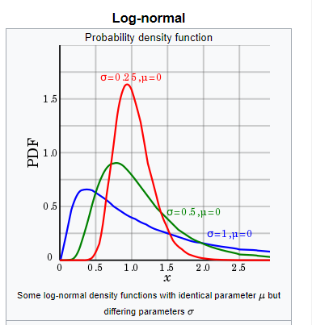

In real world there is wide presence of log normally distributed data like:

1. Comments on any website there are large no. small comments in length as compare to long comments.
2. Time spend by reader on blog, article. Most of users spend only small time on blog, very few people read the whole article.
3. The length of [chess](https://en.wikipedia.org/wiki/Chess) games tends to follow a log normal distribution
4. in [economics](https://en.wikipedia.org/wiki/Economics), there is evidence that the [income](https://en.wikipedia.org/wiki/Income) of 97%–99% of the population is distributed log-normally.

**How to check given RV is log normal distributed.**

1. Find the natural log of each observation of given RV (X) to get new RV (Y)
2. Now we plot Q-Q plot for Y against normal distribution to check whether Y is normal distributed or not.
3. If the resultant RV (Y) is normally distributed then we can say that X is log normal distribution.

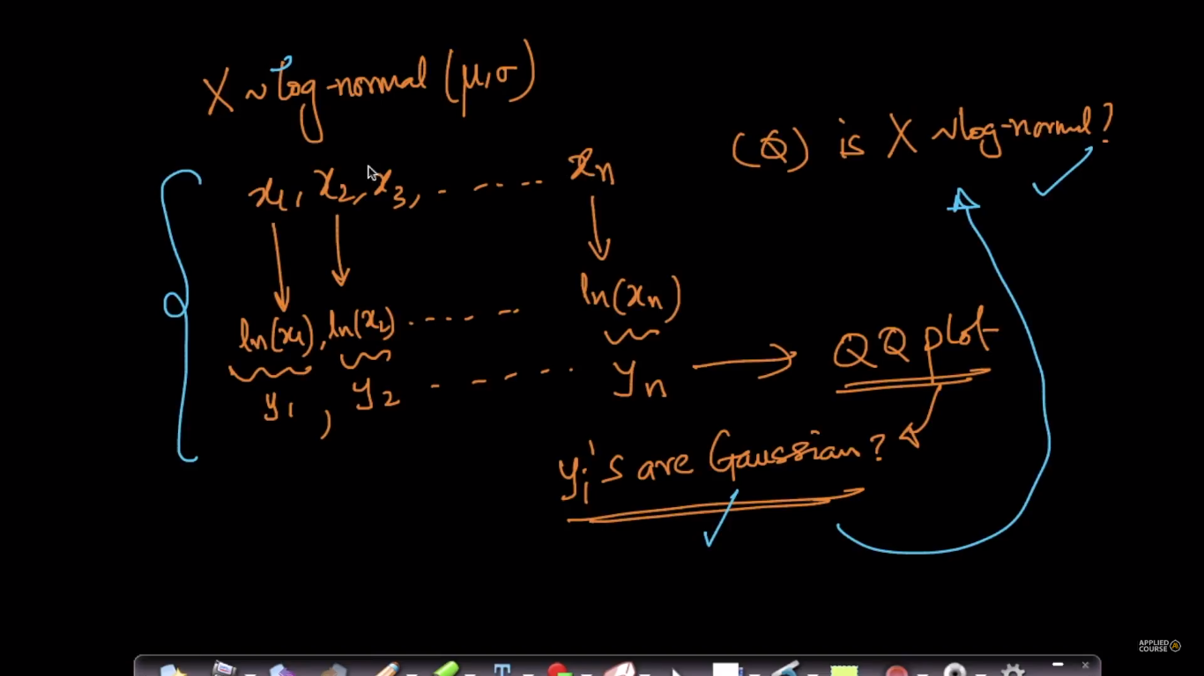

**Diff b/w normal dist & log normal dist:**

Normal distribution, we can say 50% of data present left side of mean and 50% of data present right side of mean, then we can say highest peak point in normal distribution we can assume it as mean, but not in the case of lognormal (it's skewed graph) we can't guarantee that mean will present exact at the peak point in the log normal distribution

**difference between log normal distribution and skewed distribution?**

all log-normal distributions are right-skewed, but all the skewed distributions are not log-normal.

**Conclusions:**

1. There are many real life cases follows log normal distribution : Posting comments on forums, dwelling on internet etc.

2. X ~ ln(Mu, Sigma) where ln = log normal  
3. As variance increases skewness is also increases.  
4. Log normal distribution is mostly skewed.  
5. As we all aware of there are many algorithms available to work on Normal distribution therefore we can convert log normal distribution to normal distribution  
by taking natural log. Z ~ ln(X)

